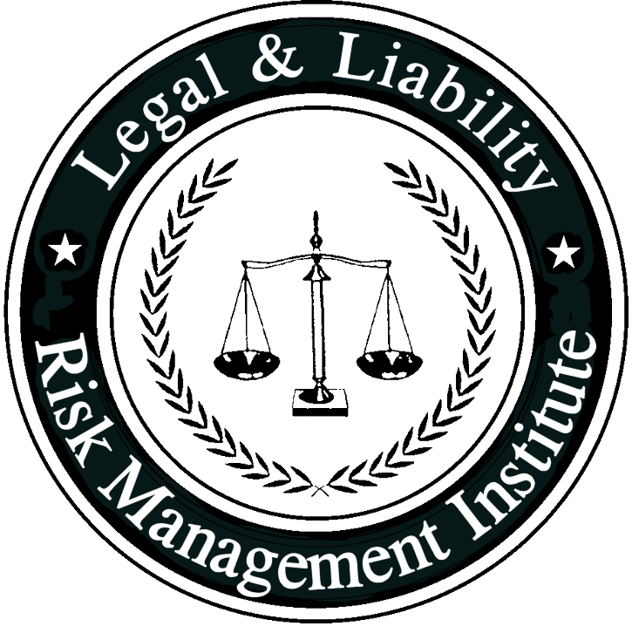

Risk Management Policy | Related Policies:
This policy is for internal use only and does not enlarge an employee’s civil liability in any way. The policy should not be construed as creating a higher duty of care, in an evidentiary sense, with respect to third party civil claims against employees. A violation of this policy, if proven, can only form the basis of a complaint by this department for non-judicial administrative action in accordance with the laws governing employee discipline.
Applicable State Statutes:
OSHA:
NFPA Standard: NFPA 1500, NFPA 1250
Date Implemented: |  | Review Date:

- Purpose: The purpose of this policy is to set forth the department’s written risk management policy in compliance with NFPA 1500 and NFPA 1250.

- Policy: It is the policy of this department for all personnel to recognize, adopt, and follow a risk management plan that complies with NFPA 1500 and 1250.

- Definitions

Risk Management: The process of planning, organizing, directing, and controlling resources and activities of an organization in order to minimize the detrimental effects on that organization

Detrimental Event: An incident or circumstance that produces or threatens to produce undesirable consequences to persons, property, or the environment that might ultimately be measured in terms of economic or financial loss.

Risk: A measure of the probability and severity of adverse effects that result from exposure to a hazard.

- Coverage:

- This risk management policy shall apply to the risks associated with the following:

- Administration

- Facilities

- Training

- Vehicle operations, both emergency and non-emergency

- Protective clothing and equipment

- Operations at emergency incidents

- Operations at non-emergency incidents

- Other related activities

- It shall be the responsibility of the Fire Chief to develop and establish a risk management plan that includes the following components:

- Risk identification: actual and potential hazards

- Risk evaluation: likelihood of occurrence of a given hazard and severity of its consequences

- Establishment of priorities for action — the degree of a hazard based upon the Frequency and risk of occurrence

- Risk control techniques — solutions for elimination or mitigation of potential hazards; implementation of best solution

- Risk management monitoring — evaluation of effectiveness of risk control techniques

- Procedure:

- Annually the Fire Chief shall appoint a five to seven person committee designated as the risk management audit committee.

- The Fire Chief shall designate a chief officer to serve as the chairperson of the committee.

- The Fire Department Safety Officer and the Director of Training shall be permanent members of the risk management audit committee.

- The committee shall convene upon the call of the chairperson, and shall meet as often as is necessary to complete the assignments required herein.

- It shall be the responsibility of the risk management audit committee to identify and evaluate each and every risk to the organization, and to fire department personnel; to prioritize those risks, and make specific recommendations to manage those risks.

- In performing their assigned duties the risk management committee shall review injury reports, accident reports, exposure reports, lawsuits and claims made against the department, and like information available from other fire departments in the state, region, and nationally.

- The risks shall be prioritized as follows:
- The committee shall submit to the Fire Chief a written report listing the risks identified, and the recommendations necessary to manage those risks.

- Within thirty days from the submission of the written report the fire chief shall prepare a written risk management plan outlining the risks and the steps necessary to manage those risks, together with a time table and plan for doing so. In preparing the risk management plan the fire chief shall not be limited to the risks identified, nor the recommendations suggested, by the risk management audit committee.

- The fire chief shall endeavor to address identified risks as soon as possible given budgetary and resources available.

- Operational Risk Management

- At all times while operating at emergency scenes, the Incident Commander shall integrate risk management into the regular functions of incident command.

- The Incident Commander shall apply the following basic risk management principles:

  - Activities that pose a significant risk to the safety of personnel shall be limited to those situations where there is a potential to save endangered lives.
  - Activities that are employed to protect property shall be conducted in such a way as to recognize the inherent risks they pose to the safety of personnel, and steps shall be taken to reduce or avoid these risks.

  - No risk to the safety of members shall be acceptable when there is no possibility to save lives or property.

- In situations where the risk to fire department personnel is excessive, activities shall be limited to defensive operations.

- The incident commander shall evaluate the risk to members with respect to the purpose and potential results of their actions in each situation.

- Risk management principles shall be employed by supervisory personnel at all levels of the incident management system to define the limits of acceptable and unacceptable positions and functions for all personnel at the incident scene.

